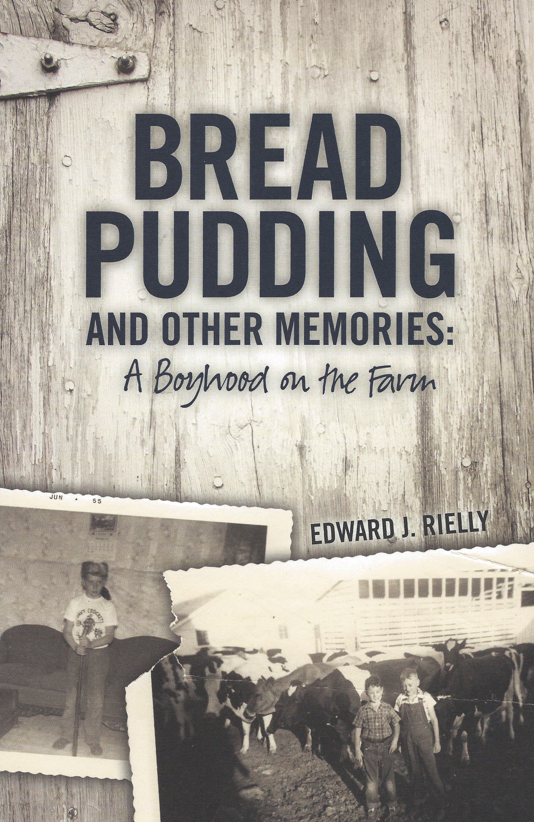

Total

**00**

**$3**

Qty.

ORDER FORM

**BREAD PUDDING** **AND OTHER MEMORIES: A Boyhood on the Farm**

**Name: _______________________________________________________**

**Address: ____________________________________________________**

**Email: _______________________________________________________ *Shipping &***

***Handling***

**Please send order form along with check**

**made payable to:** ($0.99 per book - **tax**

**for ME residents *ONLY***)

***Edward J Rielly***

**6 Colony Road**

**Westbrook, ME 04092 TOTAL**

**Questions or concerns please contact Edward Rielly at**

[erielly2@earthlink.net](mailto:erielly2@earthlink.net)

**$17.95**

Book

BREAD PUDDING

AND OTHER MEMORIES:

A Boyhood on the Farm

by Edward J. Rielly

[erielly2@earthlink.net](mailto:erielly2@earthlink.net)

B*read Pudding and Other Memories: A Boyhood on the Farm* takes the author back to his childhood on a small dairy farm in southwestern Wisconsin and the life he lived growing up in the 1940s and 50s — a way of life that has largely disappeared from the American scene. It is a world worth keeping alive, if only in memories and on the pages of a book.

Edward J. Rielly grew up on a small dairy farm in south-

western Wisconsin and attended local schools before earning a B.A. in English from Loras College in Dubuque, Iowa. He later earned a doctorate at the University of Notre Dame in eighteenth-century British literature. In 1978, he moved with his wife, Jeanne, and their children, Brendan and Brigid, to Maine, where he continues to teach writing and literature courses at Saint Joseph’s College. He has published about two dozen books, including collections of his own poetry, biographies, works on Native American history and culture, and studies of literature.

**********************************************************